BUDGET 2021
At last we have some idea of what economic recovery will look like with the 2021 Budget (delayed for the second time in as many years, albeit the first can be blamed on Brexit rather than a health-related virus). This Budget however, is not the end of uncertainty as there is to be a “Tax Day” on 23 March which promises a range of important but less high-profile measures; and as we are all painfully aware, the Devil is always in the detail.

PERSONAL TAX
Rates and allowances for 2022

A large number of hospital doctors are not entitled to a personal allowance which is the starting rate of 0% tax on income. This is lost at a rate of £1 for every £2 if taxable income exceeds £100,000 so the increase of the allowance to £12,570 (£12500 2021) may not feel relevant. It may be good news however for those who share income with lower earners, because the basic rate limit has also risen to £37,700 with effect from 6 April 2021, meaning for those with income less than £50,270 taxes will be lower this new fiscal year, but there they will stay up to and including 2026. This is of course, an effective tax rise across the work force as in real terms, inflation will bite and so any salary increases will suffer increased tax. The additional rate (45%) threshold remains at £150,000.

These changes apply equally across the UK, with the exception that Scotland has its own income tax rate bands set by the Scottish Parliament (see here for detailed information). In 2021 five income tax rates apply which range between 19% and 46%. Scottish taxpayers are entitled to the same personal allowance as individuals in the rest of the UK. The two higher rates are 41% and 46% compared to 40% and 45% for other UK residents. For 2022, 41% applies to income exceeding £43,662 for those who are entitled to the full personal allowance with 46% applying to income over £150,000. The Welsh Government has the right to vary the rates of income tax payable by Welsh taxpayers. The UK government has reduced each of the three rates of income tax paid by Welsh taxpayers by 10 pence. For 2022 the Welsh Government has set the Welsh rate of income tax at 10 pence which has been added to the reduced rates. This means tax payable by Welsh taxpayers is the same as for English and Northern Irish taxpayers.

Investment income
Dividends
Dividends are treated as the final tier of income in the tax tree of calculation. Those within the 0% dividend allowance still count towards an individual’s basic or higher rate band and for pension threshold income calculations.

Dividends received above the allowance are taxed at the following rates:
- First £2,000 @ 0% (the dividend allowance)
- 7.5% for basic rate taxpayers
- 32.5% for higher rate taxpayers
- 38.1% for additional rate taxpayers.

Savings
The savings allowance applies to savings income from banks and other interest-bearing assets. The allowance available depends on the individual’s marginal rate of income tax for the fiscal year: individuals taxed within the basic rate band have an allowance of £1,000 reduced to £500 for higher rate taxpayers and £Nil for additional rate taxpayers.

Go Green with National Savings and Investment (NS&I)
The government will offer a green retail savings product through NS&I this summer which will be aligned to the UK’s sovereign green bond framework affording all UK savers the opportunity to take part in the collective effort to tackle climate change. The green gilt framework, (to be published in June 2021), will detail types of expenditure to be financed in order to meet the government’s green objectives.
Venture Capital
It is the government’s intention to support social enterprises seeking growth investment by extending the operation of Social Investment Tax Relief to April 2023. Income tax relief and capital gains tax hold-over relief for investors in qualifying social enterprises remains available.
Car benefits
First year allowances of 100% are to be extended for zero-emission business cars and equipment for gas refuelling stations by four years from April 2021. Thresholds of CO2 emissions which determine the rate of capital allowances available through which the capital expenditure for business cars can be written down, have been amended with effect from April 2021. Reductions are
- from 50g/km to 0g/km for the purpose of the first year allowances for low CO2 emission cars; and
- from 110g/km to 50g/km for the purpose of writing down allowances (WDAs) for business cars.

The amount to which the appropriate percentage is applied in determining the taxable benefit of company car fuel is £24,600 for 2022 (£24,500 for 2021).
National insurance Class 4 limits
The Class 4 upper profits limit will increase to £50,270 in 2021/22 and remain at this level up to and including 2025/26. The lower profit limit is increased to £9,568.

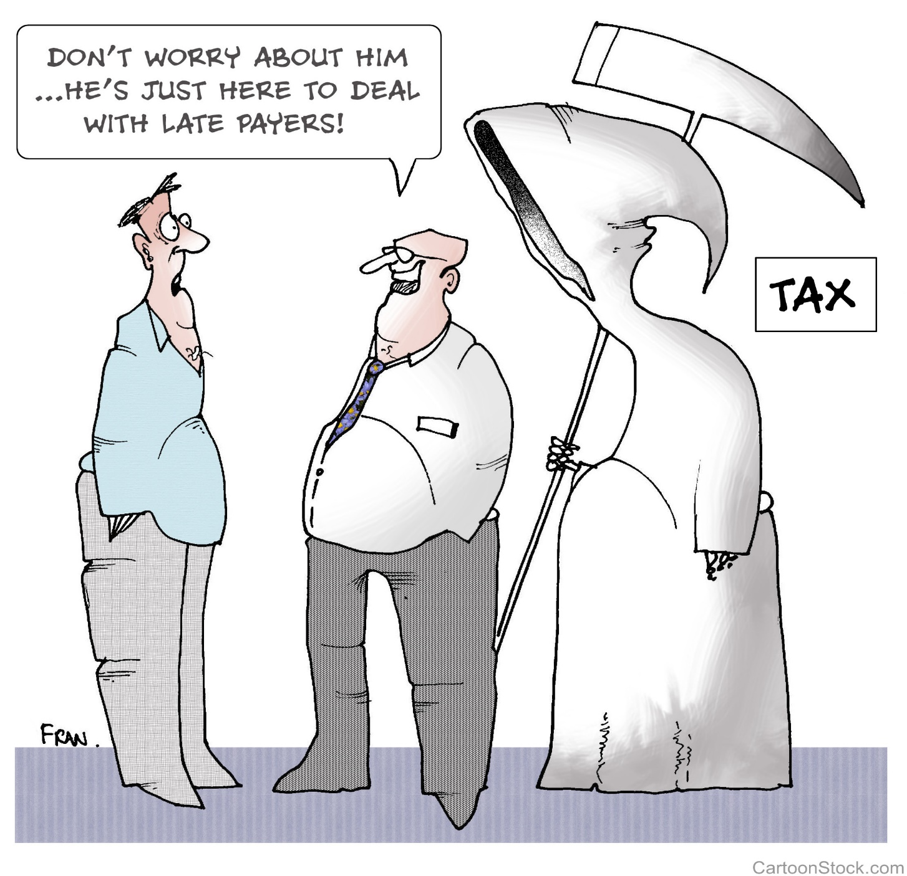
Late filing and payment penalties and interest harmonisation
A new regime is being introduced for late filing and late payment penalties for income tax self-assessment (ITSA) which will apply with effect from 6 April 2023 for taxpayers within the Making Tax Digital regime (those with business or property turnover of over £10,000 per year) and 6 April 2024 for other self-assessment taxpayers.
Late filing or submission penalties
A points-based system is being introduced such that each time a taxpayer misses a submission deadline they will incur a point. A taxpayer becomes liable to a fixed penalty of £200 upon reaching the points threshold. The threshold depends on the submission frequency: annual accrual 2 points; quarterly, 4 points; and monthly, 5 points.
The points incurred will expire after 24 months providing the taxpayer remains below the threshold. Once the threshold is reached, all points will expire if the taxpayer meets their return obligations for a set period of time. This period is based on their submission frequency: annually, 24 months; quarterly, 12 months; monthly, 6 months.
If the taxpayer continues to miss deadlines after they reach the points threshold and been issued with a penalty, they will become liable for further fixed rate penalties as additional obligations are missed. A taxpayer will not be liable if a reasonable excuse for not submitting on time is provided, and there is a right of appeal against both points and penalties.
Late payment penalties
There will be no penalty for tax paid late but within 15 days of the due date. The first penalty thereafter is set at 2% of the outstanding amount if payment is made between 16 and 30 days after the due date increasing to 4% of the outstanding amount if tax is left outstanding 30 days after the due date. A second penalty is charged at 4% per annum, calculated on a daily basis on the total amount outstanding after day 30.
To avoid or reduce penalties, the taxpayer can approach HMRC to agree a Time to Pay Arrangement. The approach is likely to have to be made in person and usually involves discussion of affordability. Our experience shows that HMRC have little sympathy for what they may consider to be extravagant lifestyle choices e.g. private school fees, expensive vehicle lease payments and an unwillingness to cash in ISAs!
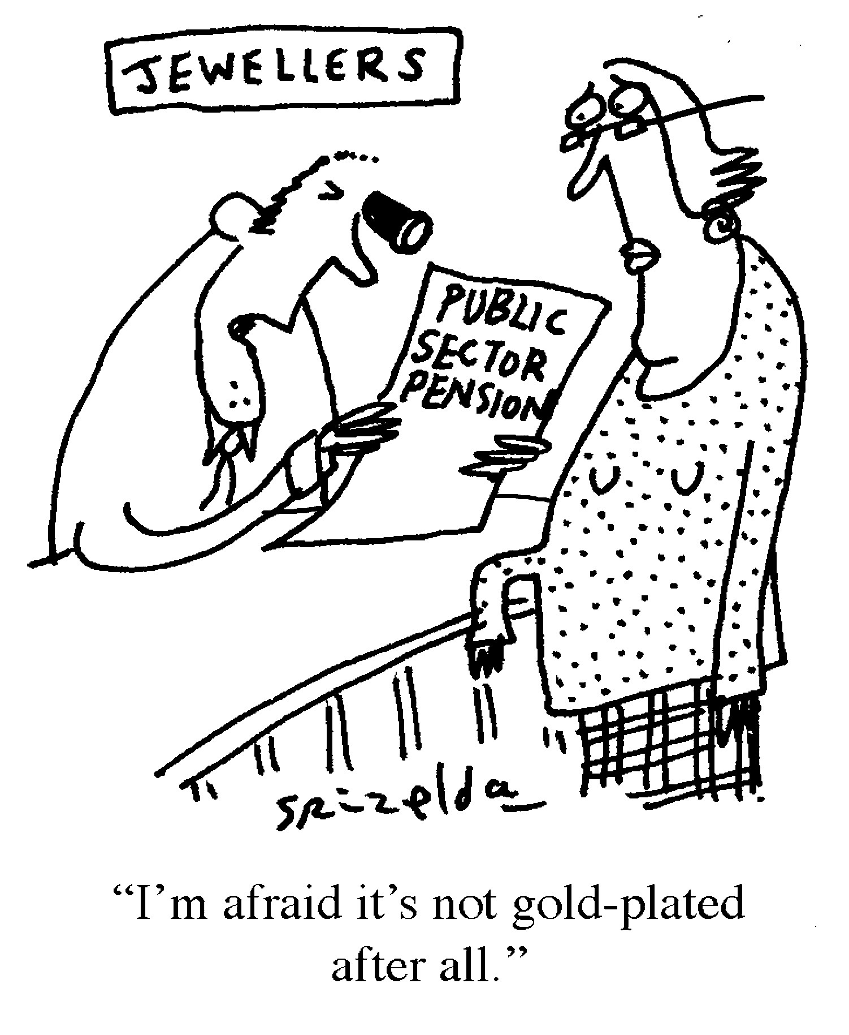
Pensions
After the McCloud judgment and the choice underpin promise (see here for detail), the government could not be expected to allow pensions to continue untouched so in line with other restrictions the link to the Consumer Price Index increase for the lifetime allowance has been removed for five years, so the allowance will remain at £1,073,100 for 2022 to 2026. This is not too far off those who have protection in place at £1.2m, and so some doctors may be considering if a return to the pension scheme, from which some in their fifties and sixties opted out, might increase their pension overall, even after tax. This is a complex area and advice should be sought.

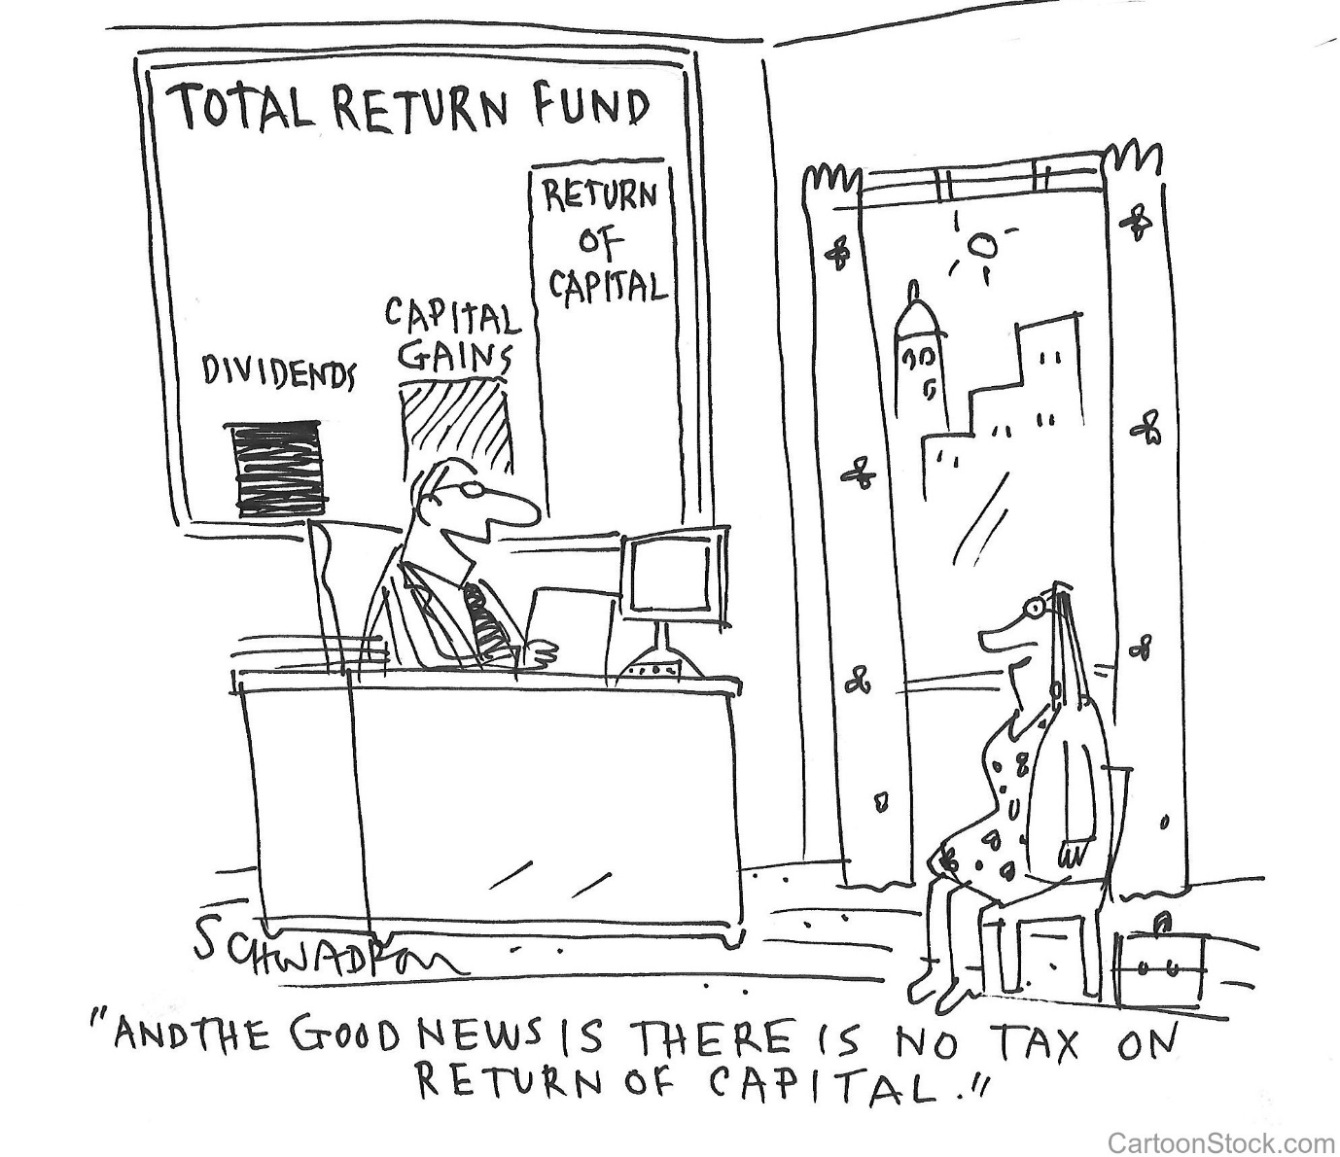
Capital Gains
Despite the report from the Office of Tax Simplification calling for changes to capital gains tax (see here for summary), there has been no movement as yet, leaving the capital gains tax annual exempt amount at £12,300 albeit remaining static up to and including 2026. The government may have thought that now is not the time for radical change, but the OTS recommendations are unlikely to be ignored. HMRC already have powers to force commercial dividend payments from reserves in companies hoarding earned profits, and we may well see this power exerted post-Covid as the economy settles.
CGT rates remain:
- at 10%, to the extent that any income tax basic rate band is available,
- and 20% thereafter.
- Higher rates of 18% and 28% apply for chargeable gains on residential properties with the exception of any element qualifying for Private Residence Relief (here).
- Types of disposal potentially qualifying for a 10% rate up to a lifetime limit for each individual:
• Business Asset Disposal Relief (BADR) (previously Entrepreneurs’ Relief) targeted at directors and employees of companies who own at least 5% of the ordinary share capital in the company, provided other minimum criteria are also met, and the owners of unincorporated businesses including LLPs/partnerships. The lifetime limit for BADR was reduced from £10 million to £1 million for BADR qualifying disposals made on or after 11 March 2020.
• Investors’ Relief is available to external investors in unquoted trading companies who have newly-subscribed shares. Investors’ Relief lifetime limit is £10 million.
Inheritance tax
Inheritance tax thresholds and rates have been frozen at £325,000 until 5 April 2026. An additional residence nil rate band (RNRB) of £175,000, for deaths in 2021 will also be frozen until 5 April 2026. A taper (unchanged) reduces the amount of the RNRB by £1 for every £2 that the ‘net’ value of the death estate exceeds £2 million. The net value is after deducting permitted liabilities but before exemptions and reliefs.
Individual savings accounts and Child trust funds
The ISA, Junior ISA and Child Trust Fund limits remain unchanged for 2022.
Mortgage guarantee scheme
The government are introducing a new mortgage guarantee scheme with effect from April 2021 which offers a guarantee to lenders across the UK who offer mortgages to individuals with a deposit of only 5% on homes demonstrating a value up to £600,000. Under the scheme, buyers are able to fix initial mortgage interest rates for at least five years, affording the opportunity to budget. The scheme, which will be available for new mortgages up to 31 December 2022, is designed to increase the availability of mortgages on new or existing properties for those with small deposits and is particularly encouraging for younger investors.
SDLT
The temporary increase in the SDLT nil rate band for residential property in England and Northern Ireland that was due to end on 31 March 2021 will be extended. The nil rate band will continue to be £500,000 for the period 8 July 2020 to 30 June 2021. From 1 July 2021 until 30 September 2021 it will be £250,000 and it will return to the standard amount of £125,000 from 1 October 2021.

England & NI Rates differ in Scotland & Wales
Residential band £ | Rate % | Non-residential rate £ | Rate %
0 - 500,000* | 0 | 0 - 150,000 | 0
501,000 – 925,000 | 5 | 150,001 - | 2
925,001 – 1,500,000 | 10 | Over £250,000 | 5
1,500,001 | 12
*£250,000 from 1 July 2021. From 1 October 2021, 0% up to £125,000, 2% from £125,001 - £250,000 and 5% from £250,001 - £925,000.
Contactless payment
Following a public consultation by the Financial Conduct Authority, the government has approved an increase to the legal contactless payment limits previously set by the European Commission. This will allow banks to support single contactless payments up to £100, and cumulative contactless payments up to £300, without the need for customers to tap in their PIN. This is likely to happen later in the year as there are some practical considerations for financial institutions.
BUSINESS TAX

Corporation tax rates
As widely anticipated the Chancellor announced an increase in the rate of corporation tax with effect from 1 April 2023. This rate will increase from 19% to 25% for companies with profits exceeding £250,000. Companies with profits of less than £50,000 will continue to be taxed at 19%. Where profits fall in between £50,000 and £250,000, the headline tax rate applied will be 25% but marginal relief on a sliding scale will be available.
This will affect a large number of hospital doctors operating private practices according to our initial research. This may necessitate a review of trading arrangements, particularly bearing in mind the potential for HMRC to question the level of dividends being paid out and reserves being retained (and essentially protected from income taxes) within a close company (a company with five or fewer shareholders).

Off-payroll working (aka IR35)
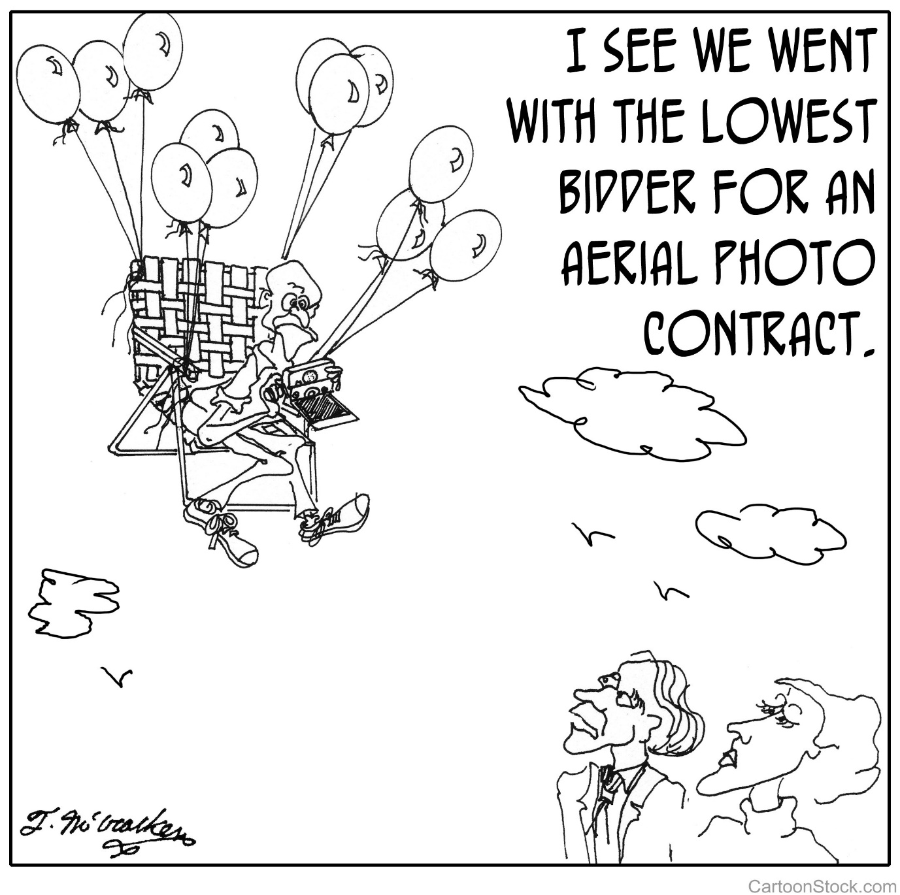
New tax rules come into force for individuals who provide their personal services via an ‘intermediary’ to a medium or large business with effect from 6 April 2021. The off-payroll working rules apply where an individual (the worker) provides their services through an intermediary (typically a personal service company) to another person or entity (the client). The client will be required to make a Status Determination Statement (SDS) of a worker’s status and communicate that determination. The client must provide this SDS to the worker and should include the decision and the reasons underpinning it. The client must take reasonable care in coming to the determination conclusion or the SDS will be rendered invalid.
The contractor (usually the organisation paying for the worker’s via their personal service company) will make deductions for income tax and NICs and more importantly, pay any employer NICs. This will make such services more expensive for all parties and is likely to reduce the number of workers willing to work without the protection of the employment rights for which essentially, they are paying. Many doctors will have received SDSs already and we are aware of many of the hospital providers taking action to educate them about these provisions. There may be SDSs which interpret how a doctor works as the tests are complicated and apply differently in different circumstances whereas larger organisations often take a broad brush approach (as has been seen with the public bodies). Appeals are allowed and we would suggest requesting assistance from your advisor as they will be familiar with IR35 and how to frame such appeals.
The new rules do not apply to small companies engaging workers under the off-payroll provisions; any determination of status in these circumstances remains with the worker. The Companies Act definition of ‘small’ is one which meets two of these criteria:
• a turnover of less than £10.2 million. If the contracting business is not a company, only this test applies
• having less than £5.1 million on the balance sheet
• employing fewer than 50 employees.
The Government are introducing a Targeted Anti-Avoidance Rule to ensure that the definition of intermediaries cannot be exploited.
COVID-RELATED
The Coronavirus Job Retention Scheme (CJRS)
The current CJRS allows an employer to put an employee on furlough leave and apply for a grant to cover salary costs for the period of furlough. The employer:
- Claims up to 80% of ‘usual salary’ for hours not worked, (maximum of £2,500 per employee) per month
- Funds employer National Insurance contributions (NICs) and the minimum employer automatic enrolment workplace pension contributions.
This CJRS has been extended further until 30 September 2021. The level of grant available to employers will remain until 30 June 2021but with effect from 1 July 2021, the grant will be reduced and employers will contribute towards the cost of furloughed employees’ wages:
- from 1 July 2021 70% of furloughed wages up to a maximum of £2187.50; and
- for August and September 2021 60% of furloughed wages up to a maximum of £1,875.00.
Eligibility forces an employer to pay furloughed employees 80% of their salaries (capped at the maximum £2,500 per month), for the time they are furloughed.

Home office equipment expenses
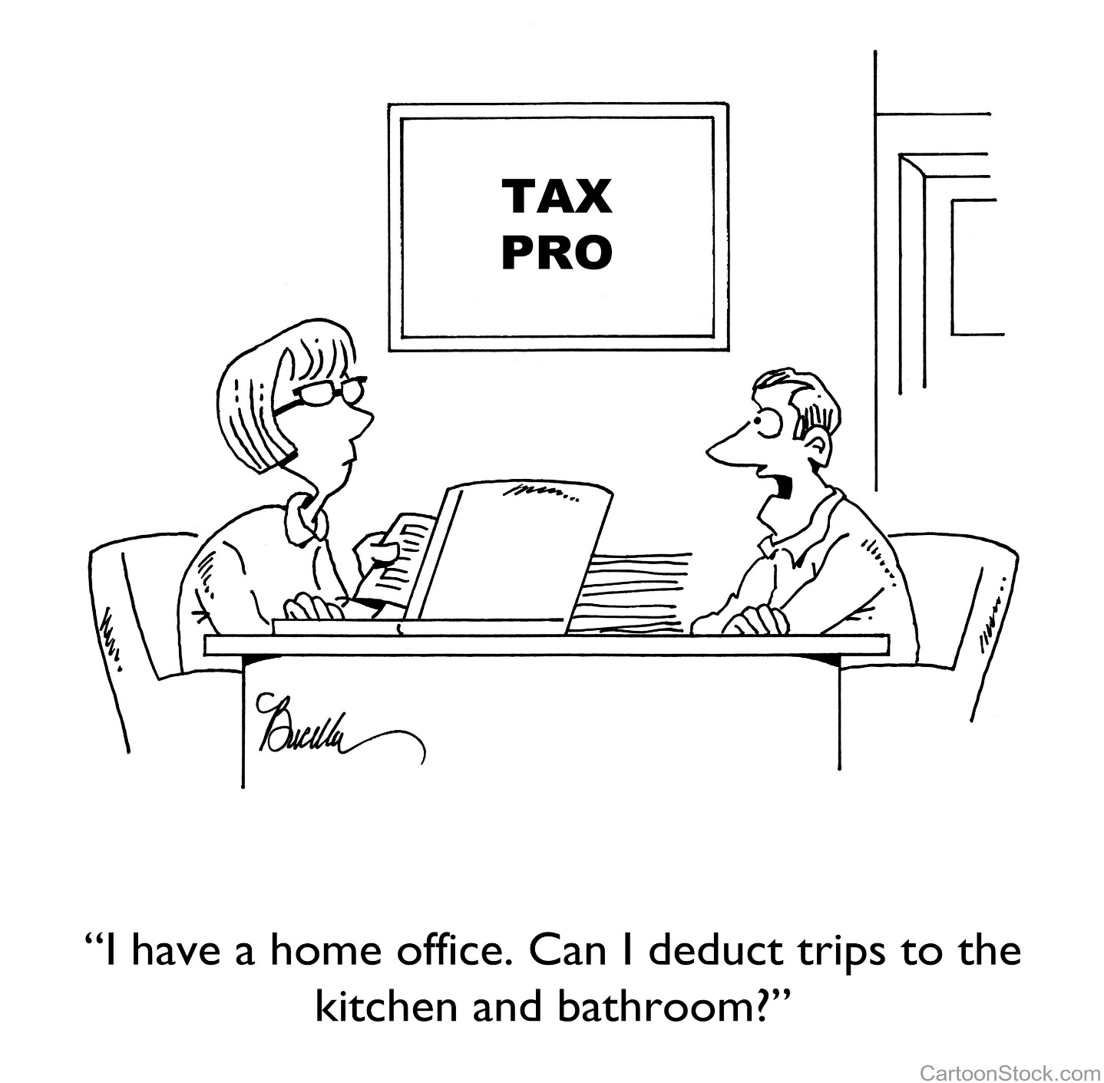

Legislation was introduced to prevent a charge to tax or NICs for amounts reimbursed to employees between 16 March 2020 (backdated by concession) and 5 April 2022 in respect of home office equipment expenses incurred by the employee in respect of equipment obtained for the sole purpose of enabling home-working during COVID. There must be no significant private use, although how this is to be policed other than by a written policy, is uncertain; and what happens to the equipment if the employee returns to the office is unknown.
Employer-provided coronavirus tests
Legislation has been extended to ensure the provision of coronavirus antigen to employees do not attract tax and NIC for 2021 and 2022. In addition the Finance Bill 2021 will introduce a retrospective income tax and NIC exemption for payments to reimburse employees for the cost of a coronavirus antigen test.
VAT AND INDIRECT TAXES
Not many hospital doctors are registered for VAT as medical services are usually exempt (detail)
VAT registration/deregistration thresholds
The VAT thresholds for registration and deregistration (£85,000 and £83,000 respectively) will be maintained until 31 March 2024.
Reduced rate for the hospitality industry extended
The reduced rate of 5% which currently applies to certain supplies relating to hospitality, hotel and holiday accommodation and admission to certain attractions will be extended until 30 September 2021.From 1 October 2021 a rate of 12.5% will then apply until 31 March 2022, after which the standard rate of 20% will revert. Regulation 55K of the VAT Regulations will be amended to ensure that businesses using the flat-rate scheme will also benefit.
New Payment Scheme in respect of deferred VAT
As a result of the pandemic, businesses have been allowed to defer VAT liabilities falling due for payment between 20 March 2020 and 30 June 2020, until 31 March 2021. Added to this is a further offer allowing businesses to pay deferred VAT in up to 11 monthly interest-free instalments but by 30 June 2021 the business must have:
• paid its liability under the deferral scheme in full;
• opted into the New Payment Scheme; or
• made alternative arrangements to pay by 30 June 2021.
A penalty of 5% of the outstanding VAT will be applied if a business has taken no action. The application of the penalty will be at the discretion of HMRC and is instead of the normal Default Surcharge regime.
Late filing and payment penalties and interest harmonisation
The new regime to be introduced for late filing and late payment penalties as explained above, will also apply for VAT on accounting periods beginning on or after 1 April 2022.
Interest harmonisation
The VAT late payment interest rules will change so that when an amount is not paid by the due date, late payment interest will be charged from the due date to the date the payment is received. Late payment interest will apply in relation to VAT returns, VAT amendments and assessments and payments on account. HMRC will normally pay repayment interest either from the last day the payment was due to be received or the day it was received, whichever is later, until the date the repayment to the taxpayer is authorised or offset.

